****

**BIRDS-3 Project**

**EM Thermal Vacuum Test Report**

Kyushu Institute of Technology

Laboratory of Spacecraft Environment Interaction Engineering





|  |  |  |  |
| --- | --- | --- | --- |
| **Date** | **Version Number** | **Writer/s** | **Annotations** |
| 2018/8/9 | v1.0 | Sasaki Y | First Draft |
| 2018/8/25 | v1.1 | Makiko | Second Version |
| 2018/8/26 | v1.2 | Abhas | Corrections + Graph Details |
|  |  |  |  |

**Contents**

1. Introduction 3

1.1. General 3

1.2. Objectives 3

1.3. Scope 3

2. Reference 3

3. Nomenclature 3

3.1. Acronyms 3

3.2. Symbols 4

4. Test Purpose 4

4.1. Overall test purpose 4

4.2. Corresponding Requirements from RAS 4

5. Test Description 5

5.1. Test Place and Time 5

5.1.1. Test Date 5

5.1.2. Test Place 5

5.2. Test Contents 5

5.3. Test Article 6

5.4. Test Flow, Level and Conditions 7

5.5. Thermal Cycle Profile as Planned 8

5.6. Actual Test Flow 9

6. Test Facility, Setup and Equipment 11

6.1. Test Facility 11

6.2. Test Setup 12

6.3. Heater Positions 14

6.4. Thermocouple Positions 16

6.5. Placement of satellite inside the small vacuum chamber 20

6.6. Equipment and Measuring Instruments 21

7. Test Schedule 21

8. Detailed Test Procedure 22

9. Test Results 24

9.1. Temperature Points and Thermal Design 24

9.1.1. External Panels, RAB and FAB 24

9.1.2 Battery and COM-UHF TRX Board 28

9.1.3. FAB, OBC, LDM, Mission2 board and RAB 33

9.1.4. Summary of Satellite Temperature Data 38

9.2. Functionality Test Results and Evaluation 39

9.3. Battery Heater Operation 39

9.4. Antenna Deployment 40

# 1. Introduction

## 1.1. General

The Thermal Vacuum Test (TVT) of the Engineering Model (EM) of BIRDS-3 satellite shall pass qualification requirements under vacuum conditions and temperature extremes which simulate predicted space environment.

## 1.2. Objectives

The following are the test objectives:

* Check and analyze various satellite point temperatures under extreme hot and cold conditions.
* Check and analyze functionality and operation of the satellite under the defined temperature range (extreme hot, extreme cold and middle temperature conditions).
* Check and analyze antenna deployment mechanism under worst cold temperature.
* Check and analyze operation of battery heater and thermal monitors under the defined temperature range.

## 1.3. Scope

This document is applied to thermal vacuum test for BIRDS-3 EM using the small vacuum chamber at the Center for Nanosatellite Testing (CENT) at Kyushu Institute of Technology (Kyutech).

# 2. Reference

|  |  |  |
| --- | --- | --- |
| **Document number** | **Document description** | **Revision level or Release date** |
| ISBN 1-884989-11-X | Spacecraft Thermal Control Handbook | Second Edition, 2002 |
| BIRDS-3 RAS | BIRDS-3 Project Requirement Allocation Sheet | Version 1 (2018/4/24) |

# 3. Nomenclature

## 3.1. Acronyms

|  |  |
| --- | --- |
| ADCS | Attitude Determination and Control System |
| CAM | Camera |
| COM-UHF TRX | UHF transceiver board |
| CW | Continuous Wave |
| EM | Engineering Model |
| EPS | Electric Power Subsystem |
| FAB | Front Access Board |
| FT | Functional Test |
| GPS | Global Positioning System |
| GS | Ground Station |
| HK | House Keeping |
| LDM | LoRa Demonstration Mission |
| LN2 | Liquid Nitrogen |
| OBC | Onboard Computer |
| PCB | Printed Circuit Board |
| RAB | Rear Access Board |
| RBF | Remove-Before-Flight |
| SP | Solar Panel |
| TC | Thermocouple |
| TVT | Thermal Vacuum Test |
| BPB | Software Defined Backplane Board |

## 3.2. Symbols

|  |  |
| --- | --- |
| °C | Degree Celsius |
| Ω | Ohm (resistance value) |
| W | Watt |
| Pa | Pascal |

# 4. Test Purpose

## 4.1. Overall test purpose

1. Measure temperatures at different satellite points under extreme hot and cold conditions.
2. Check functionality and operation of the satellite under defined temperature range (extreme hot, extreme cold and middle temperature conditions).
3. Check antenna deployment mechanism under worst cold temperature.
4. Check operation of battery heater and thermal monitors under defined temperature range.

## 4.2. Corresponding Requirements from RAS

Table 1. Requirements from RAS to be satisfied by the test

|  |  |  |
| --- | --- | --- |
| **Requirement Number**  **(from RAS)** | **Requirement Description** | **Remarks** |
| **N/A** | All of BIRDS-3’s components/parts temperature range shall be within the operating temperature ranges. | Exceptions made for EM. Tested above and below operating temperatures |
| **DR1.9.1** | BIRDS-3 shall be equipped with a heater circuit to increase internal temperature when necessary. | Battery heater placed along with insulating material for battery box |
| **DR1.10.1** | The heaters shall maintain the battery packs temperature in allowable temperature. | Heater visibly able to slow down the rate |
| **DR1.10.2** | The heaters shall not be damaged during the operation. | Heater was not damaged during the test |
| **DR1.10.3** | Heater power consumption shall be less than 1W. | Single watt heater used |
| **DR4.1.1** | Allowable internal temperature range shall be from -10ºC to 45ºC. | Exceptions made for EM. Tested above and below operating temperatures |
| **DR4.1.2** | Allowable external temperature range shall be from -40ºC to +80ºC. | Exceptions made for EM. Tested from -45ºC (all cycles) to +80ºC (final cycle) |
| **DR4.1.3** | Appropriate surface material shall be selected. |  |
| **DR4.2.1** | Suitable sensors shall be selected for the satellite temperature range. | Suitable TC were selected |
| **DR4.2.3** | Temperature measurement shall be correct within ±0.5 ºC. | Within range |
| **No assigned ID** | The battery shall be kept within temperature range (+5ºC to 35ºC). | Exceptions made for EM. Tested from -10ºC to 45ºC |

# 5. Test Description

## 5.1. Test Place and Time

### 5.1.1. Test Date

The thermal vacuum test will be conducted from **July 30 to August 3, 2018** (5 days)which includes setup preparation, the actual test cycles (with satellite functional test) and setup recovery.

### 5.1.2. Test Place

Center for Nanosatellite Testing

Laboratory of Spacecraft Environment Interaction Engineering

Kyushu Institute of technology

1-1 Sensui, Tobata, Kitakyushu, 804-8550 Fukuoka, Japan

## 5.2. Test Contents

The test shall consist of:

1. Preparation of the satellite, thermocouples (TCs), sheet heaters, connectors, GS setup and other materials to be used for the test

2. Attachment of TCs and heaters to the satellite and checking the response/resistance

3. Satellite assembly and checking of satellite functionality in normal laboratory setup (in BIRDS Room condition)

4. Installation of the satellite, TCs, heaters, and connectors inside the vacuum chamber and checking connectivity and responses.

5. Checking the satellite functionality inside the vacuum chamber before closing (atmospheric condition)

6. Vacuuming

7. Measurement of temperature of various satellite points in vacuum condition during the thermal vacuum test (especially at extreme cold condition, extreme hot condition and during the temperature transition)

8. Checking the satellite functionality during the thermal vacuum test (especially at extreme cold condition, extreme hot condition and during the temperature transition)

9. Antenna deployment test at extreme cold temperature of the Cycle 4

10. Checking battery heater operation during the thermal vacuum test

11. Setup recovery and removing the satellite from the vacuum chamber

## 5.3. Test Article

The test article description is shown in Table 2.

Table 2. Test article description

|  |  |  |  |
| --- | --- | --- | --- |
| **No.** | **Article name** | **Quantity** | **Manufacturer** |
| **1** | BIRDS-3 BPB EM | 1 | - |

The EM 3D model is shown in Figure 1.

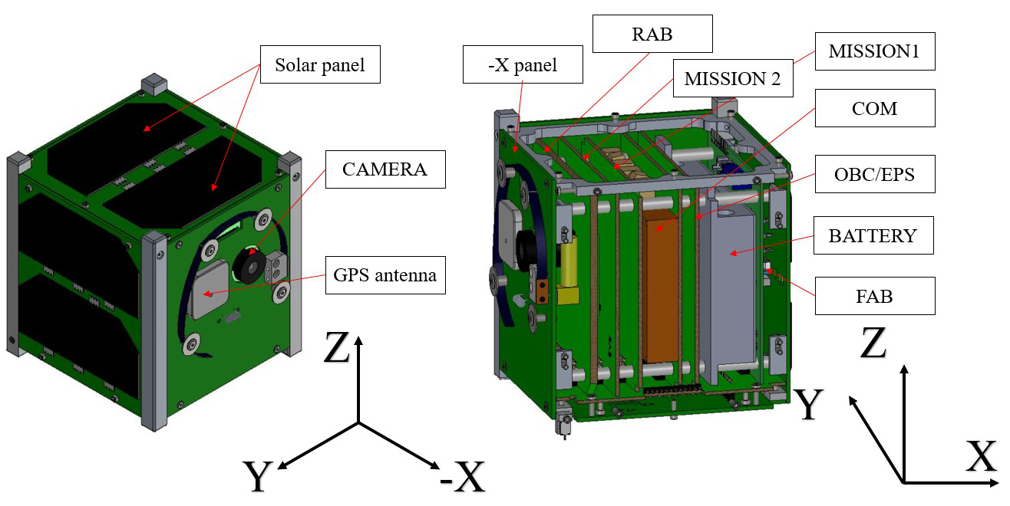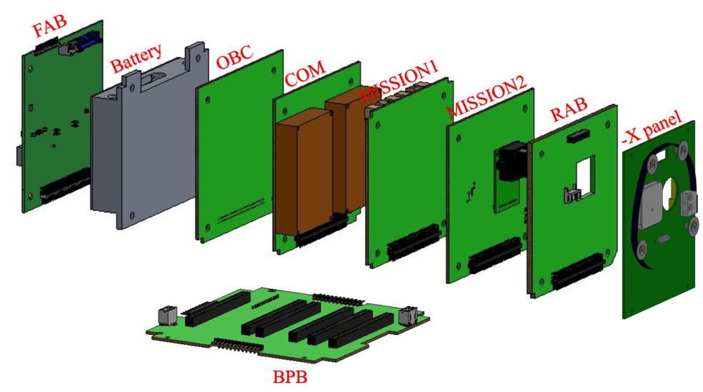

Figure 1. 3D drawing of BIRDS-3 EM

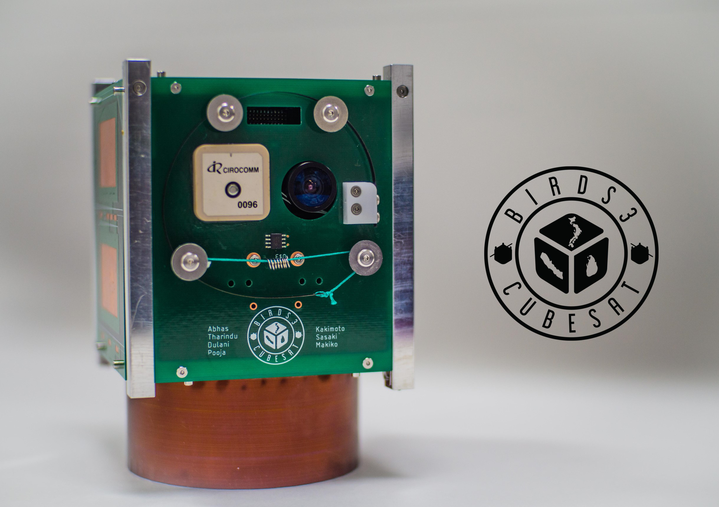

Figure 2. Actual photo of BIRDS-3 EM. The test used BPB.

Table 3 lists the operating temperature range of the different subsystems of BIRDS-3 satellite. The temperature of each subsystem during the test should be within their operating temperature range.

Table 3. Subsystem operating temperature range

|  |  |  |
| --- | --- | --- |
| **Subsystem** | **Lowest (°C)** | **Highest (°C)** |
| FAB | -40°C | +80°C |
| OBC/EPS Board | -40°C | +85°C |
| Battery | 0°C | +40°C |
| COM-UHF TRX Board | -20°C | +60°C |
| LDM Board | -40°C | +85°C |
| Mission2 Board | -20°C | +70°C |
| RAB | -40°C | +80°C |
| -X Panel | -40°C | +85°C |
| CPLD Backplane | -40°C | +105°C |

## 5.4. Test Flow, Level and Conditions

The chamber pressure should be kept below 1 x 10-3 Pa during all conditions of the thermal vacuum test. In this pressure range, heat exchange by molecular flow is negligible. Table 4 summarizes originally planned and actually targeted temperature range and number of cycle of the test. After experimenting with the first cycle, a target of -45ºC and +55ºC were taken as control temperatures.

Table 4. Temperature range and number of cycles

|  |  |  |
| --- | --- | --- |
|  | Originally Planned [1] | Targeted |
| Worst cold | -40ºC | -45 ºC |
| Worst hot | +55ºC | +55 ºC |
| Number of cycles | 4 | 4 |

[1] Based on BIRDS-2 report

## 5.5. Thermal Cycle Profile as Planned

* The test was planned to be conducted for 4 cycles (4 cold and 4 hot) as shown in Figure 3.
* At the extreme cold temperature and at the extreme hot temperature of each cycle, soaking time would be two hours with one hour for functional testing. However, this was not the case while testing. The soak lasted at least half an hour with about another half an hour for functional testing.
* There were total 10 temperature measurement points for the satellite, including the six on the external panel points.
* The monitoring/control temperature was average of six external panels.
* The worst hot condition for the external panel was +55°C.
* The battery heater of the satellite thermal subsystem would be activated at 8°C and less.
* The battery temperature was controlled to go close to 0°C. However, in real case, the battery temperature went below 0°C during functional testing.

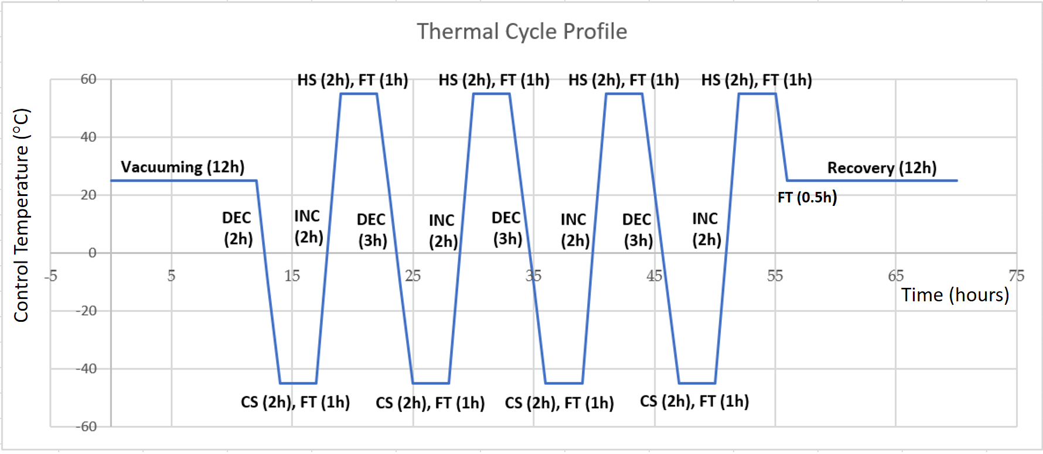

Figure 3. Thermal cycle profile as planned

## 5.6. Actual Test Flow

The actual test flow, as estimated from the measured temperature profile, is summarized in Table 5.

Table 5. Actual test flow executed (estimated from measured temperature profile)

|  |  |  |  |  |
| --- | --- | --- | --- | --- |
| Phase | | | Duration  (Hours) | Time (Hour) |
| Chamber closing, start of vacuuming | | | - | 0  (= reference time) |
| Vacuuming, room temperature | | | ~17 | ~17 |
| FT trials before LN2 | | | 1 | 18 |
| Cold Ramp 1 | Start | | 2 | 20 |
| Cold Ramp 1 | Stop | |
| Cold Soak 1 | Start | | 0.5 | 20.5 |
| Cold Soak 1 | Stop | |
| FT |  | | 0.5 | 21 |
| Hot Ramp 1 | Start | | 1.3 | 22.3 |
| Hot Ramp 1 | Stop | |
| Hot Soak 1 | Start | | 1 | 23.3 |
| Hot Soak 1 | Stop | |
| FT |  | | 0.5 | 23.8 |
| Cold Ramp 2 | Start | | 3 | 26.8 |
| Cold Ramp 2 | Stop | |
| Cold Soak 2 | Start | | 0.7 | 27.5 |
| Cold Soak 2 | Stop | |
| FT |  | | 0.5 | 28 |
| Hot Ramp 2 | Start | | 2.5 | 30.5 |
| Hot Ramp 2 | Stop | |
| Hot Soak 2 | Start | | 1 | 31.5 |
| Hot Soak 2 | Stop | |
| FT |  | | 0.5 | 32 |
| Cold Ramp 3 | Start | | 2 | 34 |
| Cold Ramp 3 | Stop | |
| Cold Soak 3 | Start | | 1 | 35 |
| Cold Soak 3 | Stop | |
| FT |  | | 0.5 | 35.5 |
| Hot Ramp 3 | Start | | 1.5 | 37 |
| Hot Ramp 3 | Stop | |
| Hot Soak 3 | Start | | 1 | 38 |
| Hot Soak 3 | Stop | |
| FT |  | | 0.5 | 38.5 |
| Cold Ramp 4 | Start | | 3 | 41.5 |
| Cold Ramp 4 | Stop | |
| Cold Soak 4 | Start | | 1.5 | 43 |
| Cold Soak 4 | Stop | |
| FT |  | | 0.5 | 43.5 |
| Hot Ramp 4 | Start | | 2 | 45.5 |
| Hot Ramp 4 | Stop | |
| Hot Soak 4 | Start | | 1 | 46.5 |
| Hot Soak 4 | Stop | |
| FT | | | 0.3 | 46.8 |
| Hot Ramp Ex. | | Start | 0.2 | 47 |
| Hot Ramp Ex. | | Stop |
| Hot Soak Ex. | | Start | 0.4 | 47.4 |
| Hot Soak Ex. | | Stop |
| FT | | | 0.3 | 47.7 |
| FT trials in vacuum at room temperature | | | 10.8 | 58.5 |
| De-vacuuming and recovery | | | 2 | 60.5 |
| FT trials in atmospheric room condition | | | 0.3 | 60.8 |

# 6. Test Facility, Setup and Equipment

## 6.1. Test Facility

Specifications of the thermal vacuum chamber are given in Table 6.

Table 6. Small thermal vacuum chamber specification

|  |  |  |
| --- | --- | --- |
| No. | Items | Specification |
| 1 | Name | Vacuum thermal shock test equipment |
| 2 | Manufacturer | ULVAC KYUSHU CORPORATION |
| 3 | Size | Overall length 100 (each tub 50) x Ф30 |
| 4 | Material | SUS 304 |
| 5 | Ultimate Vacuum | 1.0 x 10-5 Pa ~ 1.0 x 10-3 Pa |
| 6 | Temperature | -150ºC ~ +150ºC |
| 7 | Thermal Input | No rail: shroud (cold), sheet heater (hot)  With rail: shroud (cold), IR lamp (hot) |
| 8 | Dimensions | No rail: 200 x 150 x 150  With rail: 100 x 100 x 100 |
| 9 | Characteristics | -Separate into hot and low temperature side  -Simulate exponential thermal input by moving a satellite in the chamber |

Figure 4 shows a photo of CeNT’s small thermal vacuum chamber.

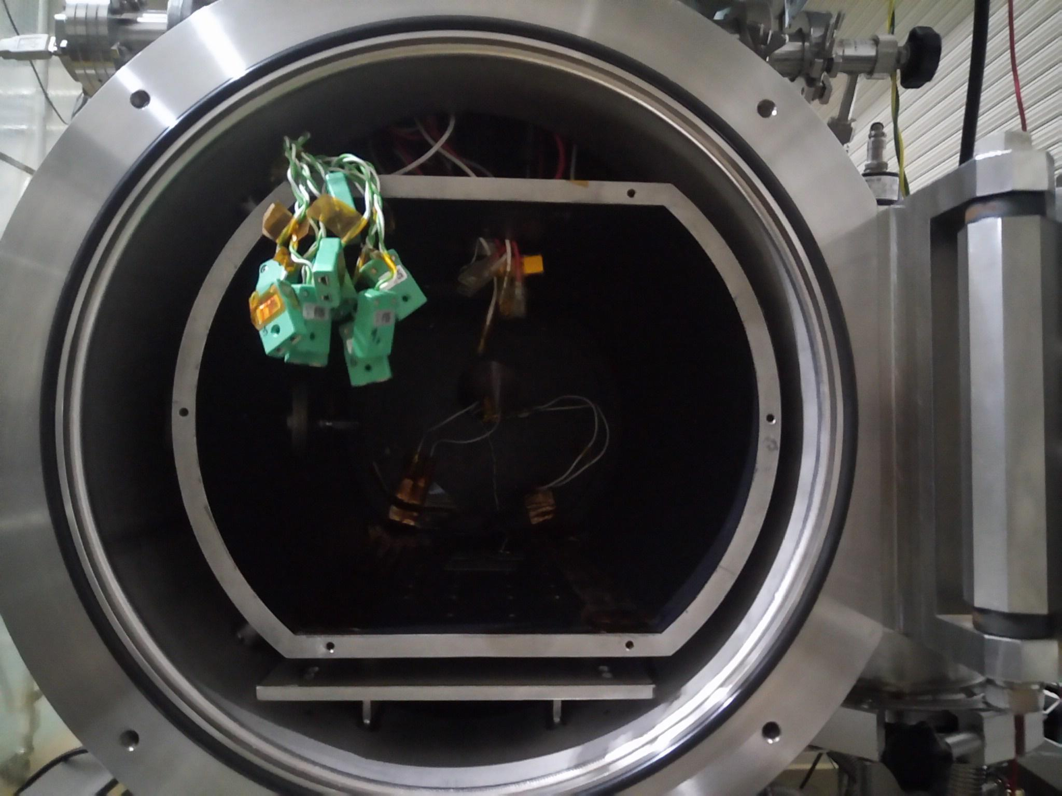

Figure 4. Small thermal vacuum chamber at CeNT

## 6.2. Test Setup

The setup diagrams are shown below, Figure 5 to 7.

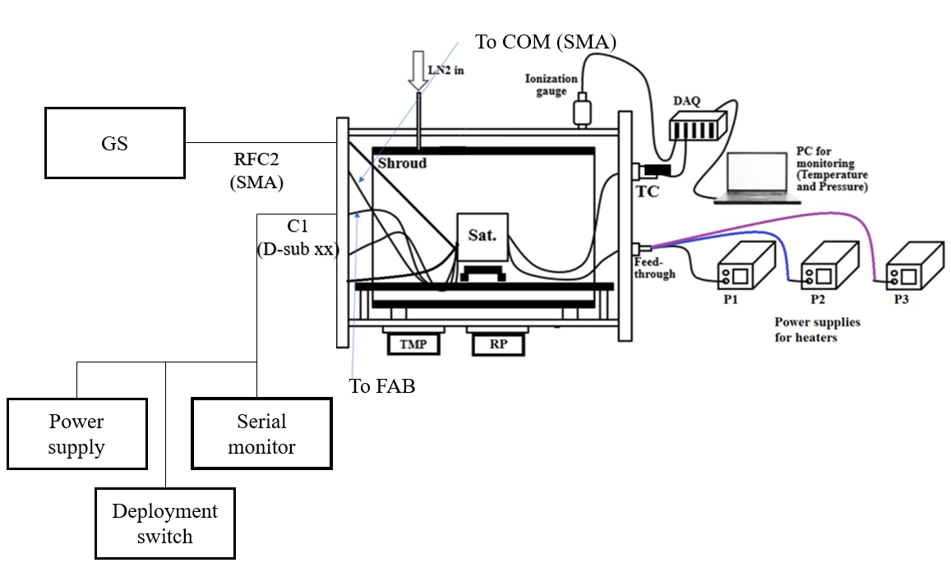

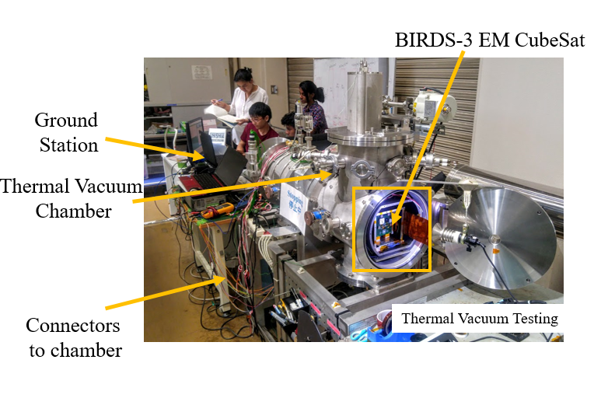

Figure 5. Overall test setup: diagram (upper), actual (lower)

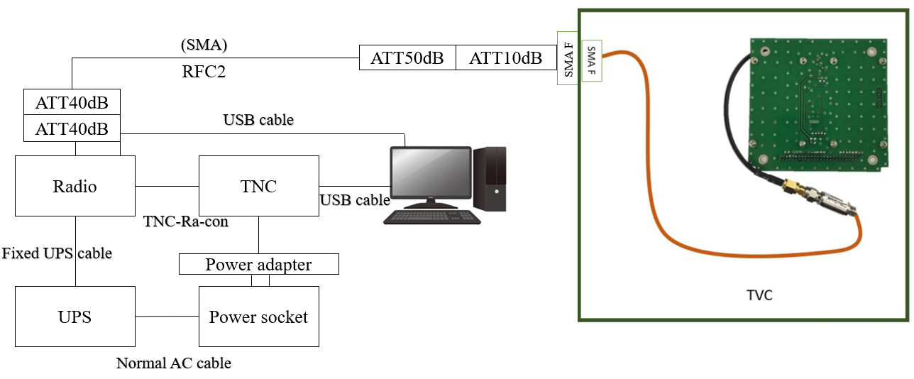

Figure 6. Connection from COM-UHF to GS equipment

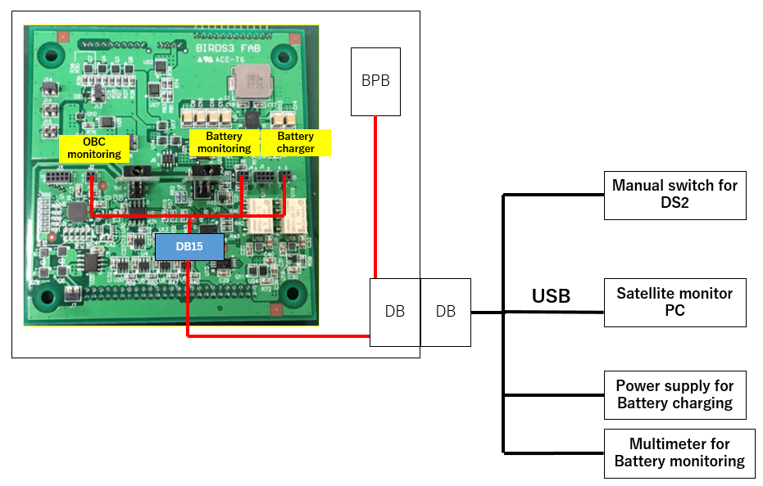

Figure 7. Connection from FAB to programming board, satellite monitoring PC, manual switch for RBF and power supply for battery charging

## 6.3. Heater Positions

Table 7 provides the sheet heater positions and parameters such as, size, resistance and maximum power that can be used for the test.

|  |  |
| --- | --- |
| Parallel |  |

Table 7. Heater Parameters

|  |  |  |  |  |  |  |
| --- | --- | --- | --- | --- | --- | --- |
| Heater Number | Position | Size [mm] | Resistance (Ω) | Total Resistance (Ω) | Maximum Power (W) | Power Supply Number |
| H1 | -Y, -X | 300 mm x 100 mm | 28.5 | ~14.5 |  | P1 |
| H2 | +Y | 300 mm x 100 mm | 29 |  | P1 |
| H3 | +X, Z | 300 mm x 100 mm | 28.5 | 28.5 |  | P2 |
| H4 | -Z | 165 mm x 105 mm | 12.5 | 12.5 |  | P3 |

The placement of the sheet heaters is shown in Figure 8, below. In the final setup.

After attachment

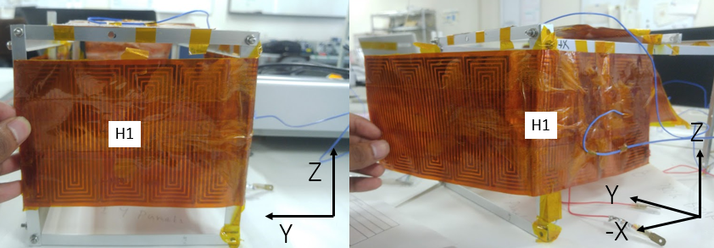

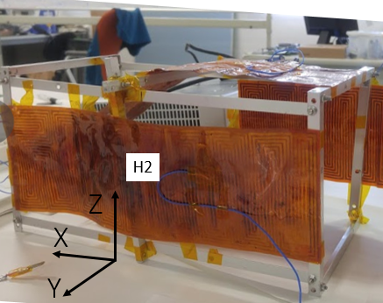

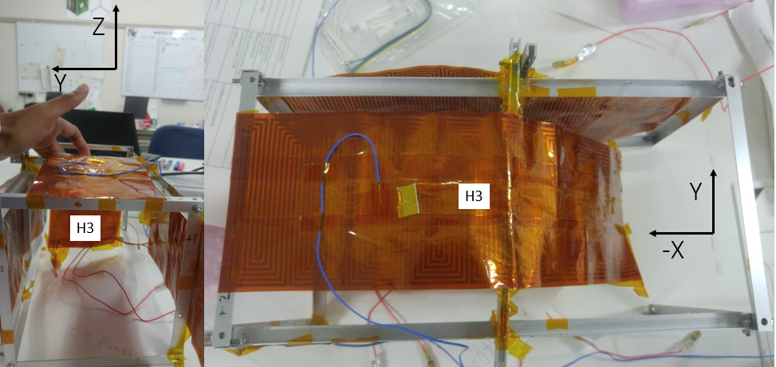

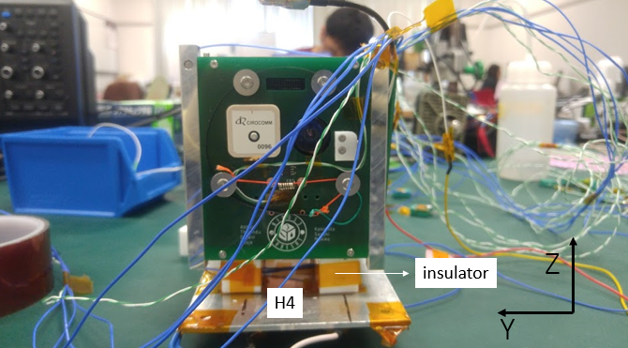

Figure 8. Positions of sheet heaters

## 6.4. Thermocouple Positions

The positions of thermocouples are summarized in Table 7.

Table 7. Positions of thermocouples

|  |  |  |  |  |  |
| --- | --- | --- | --- | --- | --- |
|  | **Position** | **TC Number** | **Connector Number Inside of Chamber** | **TC Number in PC** | **Measurement Point** |
| **1** | Shroud Top |  |  | 9 |  |
| **2** | Shroud Bottom |  |  | 10 |  |
| **3** | LN2 Control |  |  | 11 |  |
| **4** | Battery Box – Front | K01 |  | 0 | Figure 9 |
| **5** | Battery Box – Back | K02 |  | 1 | Figure 10 |
| **6** | Battery – Inside Battery Box | K03 |  | 2 | Figure 11 |
| **7** | Front Access Board | K04 |  | 3 | Processor, Figure 12 |
| **8** | OBC Board | K05 |  | 4 | Processor, Figure 13 |
| **9** | COM-UHF TRX Board | K06 |  | 5 | Processor, Figure 14 |
| **10** | LDM Board | K07 |  | 6 | Processor, Figure 15 |
| **11** | Mission2 Board | K08 |  | 7 | Processor, Figure 16 |
| **12** | Rear Access Board | K09 |  | 8 | Figure 17 |
| **13** | -X | K10 |  | 12 | Near Nichrome Wire Figure 18 |
| **14** | +X | K11 |  | 13 | Figure 19 |
| **15** | +Y | K12 |  | 14 | Figure 20 |
| **16** | -Y | K13 |  | 15 | Figure 21 |
| **17** | +Z | K14 |  | 16 | Figure 22 |
| **18** | -Z | K15 |  | 17 | Figure 23 |
| **19** | CPLD Backplane Board | K16 |  | 18 | CPLD, Figure 24 |
| **20** | H1 | K20 |  | 19 | Figure 8 |
| **21** | H2 | K17 |  | 20 | Figure 8 |
| **22** | H3 | K18 |  | 21 | Figure 8 |
| **23** | H4 | K19 |  | 22 | Figure 8 |

Figures 8 to 24 show the position of thermocouples will be attached to the satellite.

|  |  |
| --- | --- |
| Figure 9. Battery Box – Front Side (K01) | Figure 10. Battery Box – Back Side (K02) |
|  |  |
| Figure 11. Battery – Inside Battery Box (K03) | Figure 12. Front Access Board (K04) |
|  |  |
| Figure 13. OBC Board (K05) | Figure 14. COM-UHF TRX Board (K06) |
|  |  |
| Figure 15. LDM Board (K07) | Figure 16. Mission Board II (K08) |
|  |  |
| Figure 17. Rear Access Board (K09) | Figure 18. -X External Panel (K10) |
|  |  |
| Figure 19. +X External Panel (K11) | Figure 20. +Y External Panel (K12) |
|  |  |
| 図2  Figure 21. –Y External Panel (K13) | Figure 22. +Z External Panel (K14) |
|  |  |
| Figure 23. -Z External Panel (K15) | S__73023493  Figure 24. CPLD Backplane Board (K16) |
|  |  |
|  |  |

Figure 25. Photos of the satellite after attachment of thermocouples and heaters

## 6.5. Placement of satellite inside the small vacuum chamber

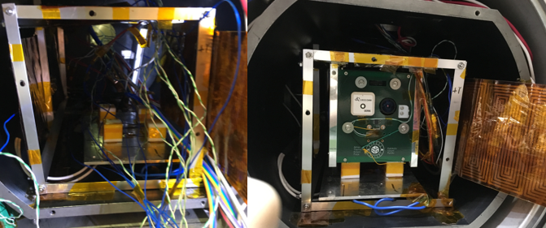

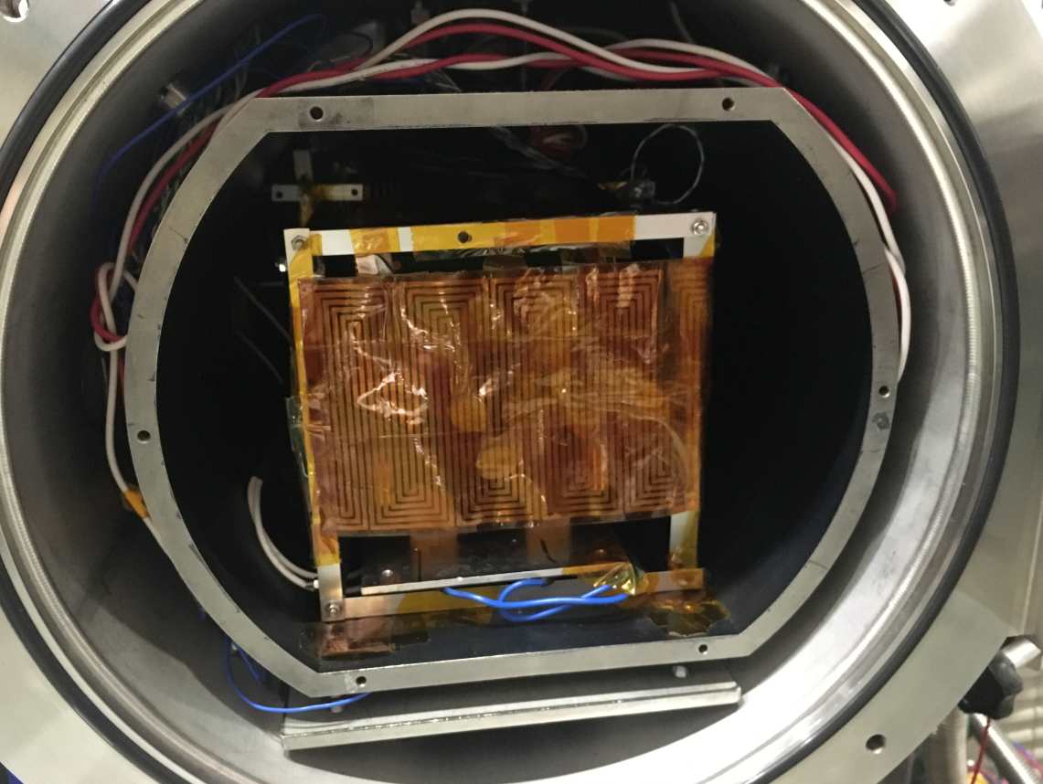

Figure 26. Placement of satellite inside the small vacuum chamber

## 6.6. Equipment and Measuring Instruments

Table 8 provides a list of equipment used during the thermal vacuum test.

Table 8. Equipment and measuring instruments details

|  |  |  |  |  |  |
| --- | --- | --- | --- | --- | --- |
| No | Equipment | Quantity | Model | Comments | |
| 1 | Thermocouple | 23 | Type-K | -180°C to +1300 °C |
| 2 | 80 W Sheet Heater | 3 | PS50200 | ~90 Ω |
| 3 | 20 W Sheet Heater | 4 | PS25100 | ~25 Ω |
| 4 | Data acquisition PC | 1 | Desktop PC | For chamber control |
| 5 | DAQ-mx | 3 | NI 9213 | 24 bit ADC |
| 6 | Power Supply | 4 |  | 0-320V |
| 7 | GS Transceiver | 1 | IC-9100 | For functional test |
| 9 | Attenuators | 3 |  | For functional test |
| 10 | Functional Test PC | 2 | N/A | For functional test |
| 11 | Terminal Node Controller | 1 | KPC-9612+ | For functional test |

# 7. Test Schedule

The actual test schedule is shown in Table 9.

Table 9. Test schedule

|  |  |  |  |  |  |  |  |  |  |
| --- | --- | --- | --- | --- | --- | --- | --- | --- | --- |
|  | 7/30  AM | 7/30  PM | 7/31  AM | 7/31  PM | 8/1  AM | 8/1  PM | 8/2  AM | 8/2  PM | 8/3  AM |
| Preparation of the satellite, thermocouples (TCs), sheet heaters, connectors, GS setup and other materials to be used for the test |  |  |  |  |  |  |  |  |  |
| Attachment of TCs and heaters to the satellite and checking the response/resistance |  |  |  |  |  |  |  |  |  |
| Satellite assembly and checking of satellite functionality in normal laboratory setup (in BIRDS-3 Room condition)  Installation of the satellite, TCs, heaters, and connectors inside the vacuum chamber and checking connectivity and responses. |  |  |  |  |  |  |  |  |  |
| Checking the satellite functionality inside the vacuum chamber before closing (atmospheric condition) |  |  |  |  |  |  |  |  |  |
| Vacuuming |  |  |  |  |  |  |  |  |  |
| Inject LN2 |  |  |  |  |  |  |  |  |  |
| Thermal Cycle |  |  |  |  |  |  |  |  |  |
| De-vacuuming, setup recovery and removing the satellite from the vacuum chamber |  |  |  |  |  |  |  |  |  |

# 8. Detailed Test Procedure

The detailed test procedure checklist is given in Table 10.

Table 10. Detailed test procedure checklist

|  |  |  |  |  |
| --- | --- | --- | --- | --- |
| **No.** | **Test** | **Procedure** | **Check/Measurement** | **Comments** |
| 0 |  | Verify all satellite functionalities and operation (preliminary, in BIRDS-3 Room) | ✔ |  |
| 1 | Preparation and checking the satellite and chamber | Prepare and check thermocouples | ✔ |  |
| 2 | Prepare and check heaters | ✔ |  |
| 3 | Check chamber's heater connections | ✔ |  |
| 4 | Check chamber's thermocouple connections | ✔ |  |
| 5 | Check chamber's D-Sub and RF port connections | ✔ |  |
| 6 | Disassemble structure and center box | ✔ |  |
| 7 | Attach thermocouples and heaters to BIRDS-3 CubeSat | ✔ |  |
| 8 | Take photos and note the heaters’ and TCs’ positions | ✔ |  |
| 9 | Reassemble satellite and check thermocouples and heaters connection | ✔ |  |
| 10 | Check satellite functionalities | ✔ |  |
| 11 | Move satellite to the chamber | ✔ |  |
| 12 | Install the satellite in the chamber | ✔ |  |
| 13 | Check again all heaters’ and TCs’ response on the PC | ✔ |  |
| 14 | Check satellite functionalities | ✔ |  |
| 15 |  | Close the chamber | ✔ |  |
| 13 | Make vacuum and conduct the thermal test and functional test | Make vacuum | ✔ |  |
| 14 | Inject LN2 | ✔ |  |
| 15 | Start cold ramp 1 | ✔ |  |
| 16 | Start cold soak 1 | ✔ |  |
| 17 | Satellite functional test 1-C | ✔ |  |
| 18 | Start hot ramp 1 | ✔ |  |
| 19 | Start hot soak 1 | ✔ |  |
| 20 | Satellite functional test 1-H, battery charging | ✔ |  |
| 21 | Start cold ramp 2 | ✔ |  |
| 22 | Start cold soak 2 | ✔ |  |
| 23 | Satellite functional test 2-C | ✔ |  |
| 24 | Start hot ramp 2 | ✔ |  |
| 25 | Start hot soak 2 | ✔ |  |
| 26 | Satellite functional test 2-H, battery charging | ✔ |  |
| 27 | Start cold ramp 3 | ✔ |  |
| 28 | Start cold soak 3 | ✔ |  |
| 29 | Satellite functional test 3-C | ✔ |  |
| 30 | Start hot ramp 3 | ✔ |  |
| 31 | Start hot soak 3 | ✔ |  |
| 32 | Satellite functional test 3-H, battery charging | ✔ |  |
| 33 | Start cold ramp 4 | ✔ |  |
| 34 | Start cold soak 4 | ✔ |  |
| 35 | Satellite functional test 4-C | ✔ |  |
| 36 | Start hot ramp 4 | ✔ |  |
| 37 | Start hot soak 4 | ✔ |  |
| 38 | Satellite functional test 4-H, battery charging | ✔ |  |
| 39 | Start ramp down to room temperature | ✔ |  |
| 40 | Satellite functional test at room temperature | ✔ |  |
| 41 | Stop the test, clean up and check the satellite | Stop LN2 injection | ✔ |  |
| 42 | Turn on chamber heater to increase chamber temperature | ✔ |  |
| 43 | Open chamber, move satellite to clean room | ✔ |  |
| 44 | Satellite functional testing | ✔ |  |
| 45 | Disassemble satellite | ✔ |  |
| 46 | Remove TCs and heaters | ✔ |  |

# 9. Test Results

## 9.1. Temperature Points and Thermal Design

### 9.1.1. External Panels

The temperatures of the six external panels are plotted in Figure 27.

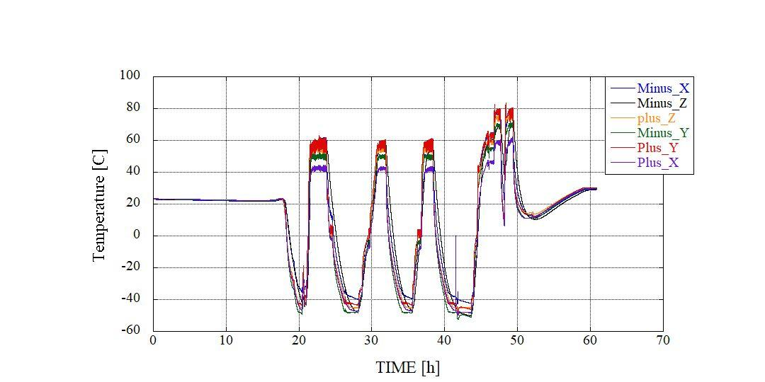

Vacuum reached

Figure 27. Temperature plots of six external panel throughout the test

The external temperatures were controlled from -45 ºC and -55 ºC. Each cycle had a soak- both cold and hot- for 30 minutes. The functional test was then conducted. In the first cycle, a cold start was initiated. The satellite remained turned on for the whole testing from then on. The fourth cycle was an experimental cycle where the cold soak was extended till the temperature of the battery reached -10ºC and functional test conducted. The external panel control was placed at 80ºC for the fourth hot soak. Fig. 28 shows the how at the final cycle differs from the normal cycles.

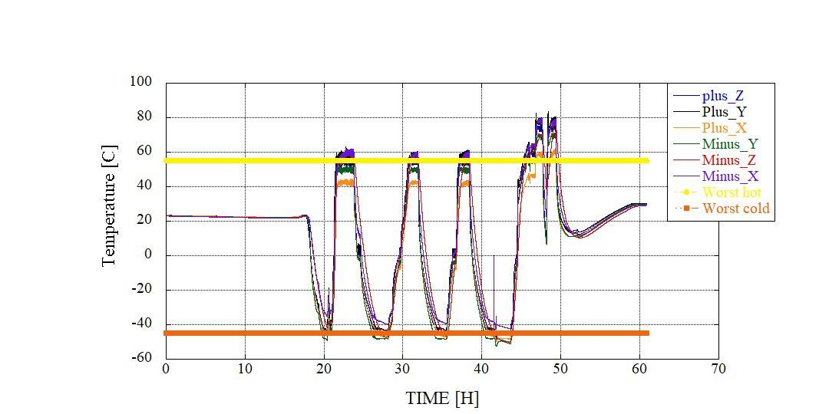

Figure 28. Plot of newly defined control temperature

Detailed temperature plots of the external panels are given in Figures 29 to 35.

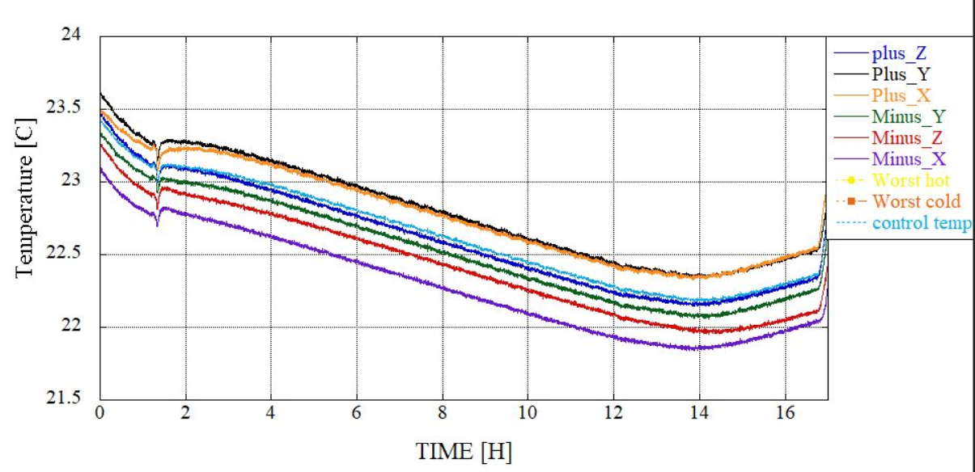

Figure 29. Temperature plots of external panels before LN2 injection

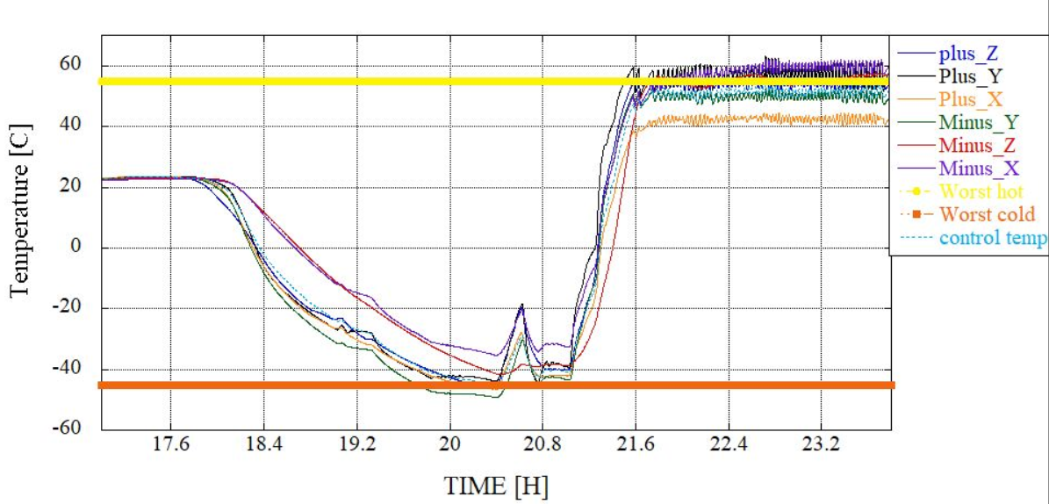

Figure 30. Temperature plots of external panels during 1st cycle

The sharp rise and fall in temperature during cold soak was due to COM’s temperature reaching -35 ºC when the team was focused on the temperature of the battery which had not yet reached 0 ºC. The cold start was supposed to begin when the temperature of the battery reached at the minimum operating temperature. The control temperature was brought down to -45 ºC after deciding that the COM could still respond. The cold start was successful and functional test showed no issue.

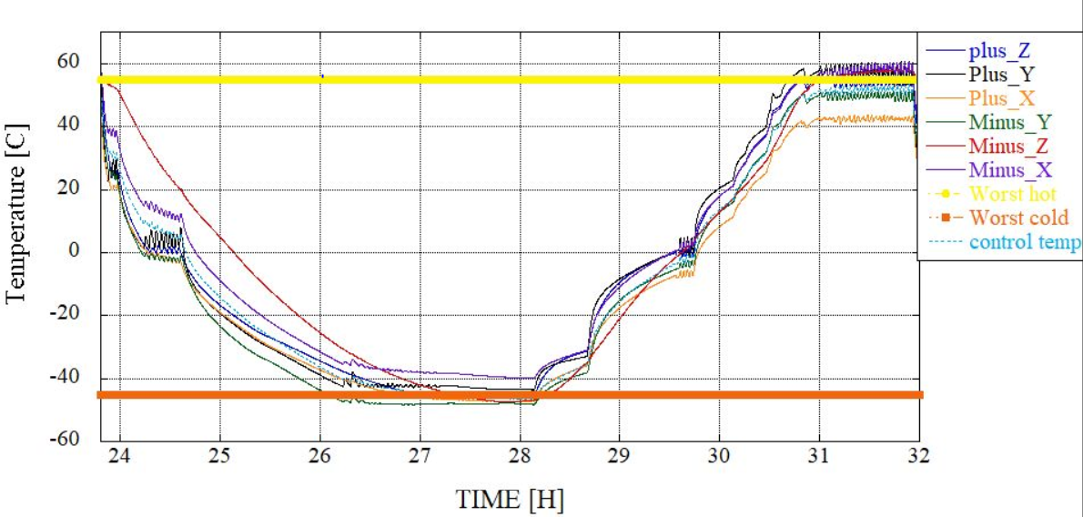

Figure 31. Temperature plots of external panels during 2nd cycle

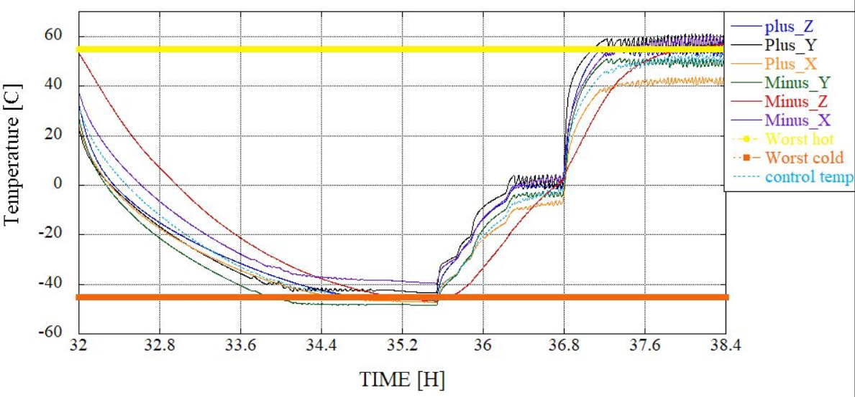

Figure 32. Temperature plots of external panels during 3rd cycle

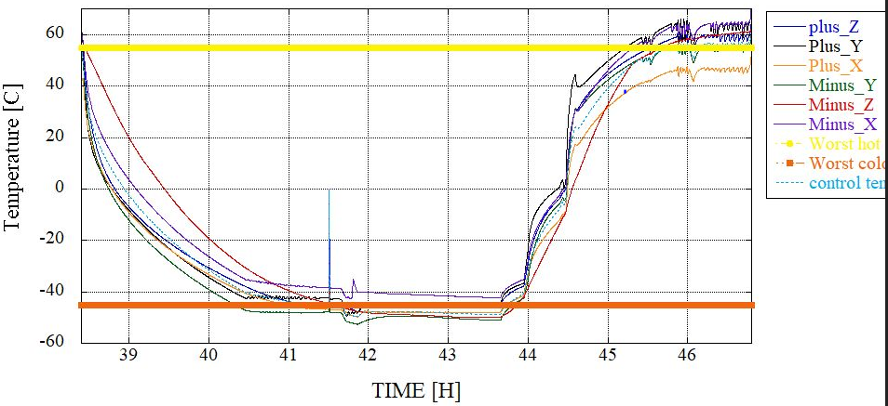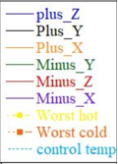

Figure 33. Temperature plots of external panels during 4th cycle

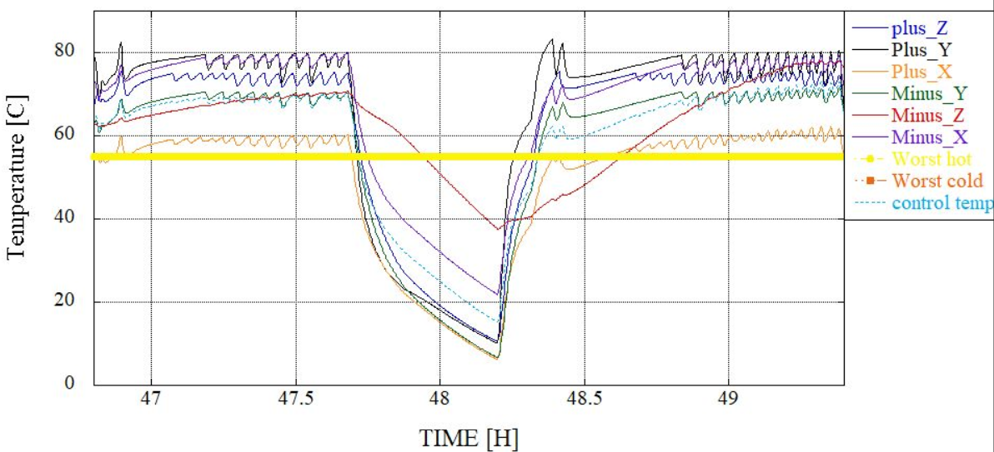 Figure 34. Temperature plots of external panels during experimental cycleA

During the hot soak of the fourth cycle at 80ºC, the Main PIC stopped responding at 60ºC. The temperature was then brought down to 50ºC of the Main PIC and then brought back up to just over 60ºC to check whether the PIC would respond. This time, there was no issue.

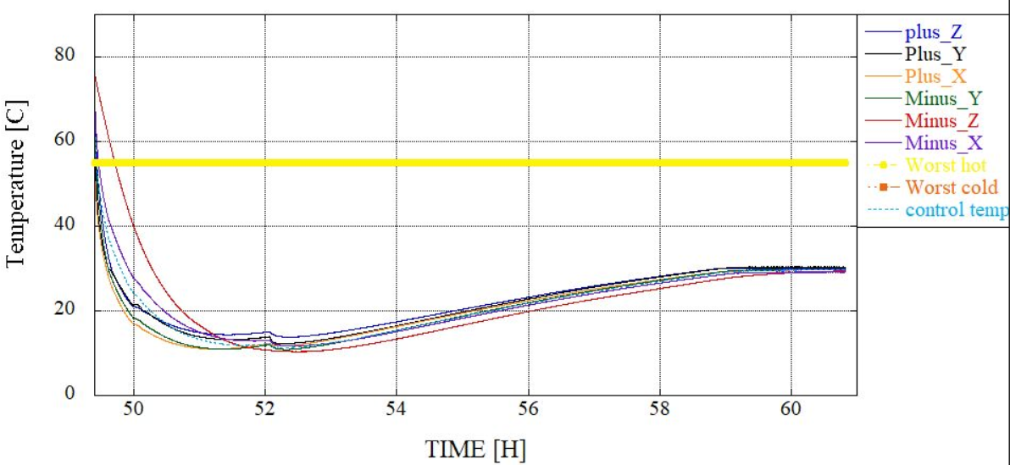

Figure 35. Temperature plots of external panels during recovery

### 9.1.2 Battery and COM-UHF TRX Board

The temperatures inside and outside of battery box and on COM-UHF TRX board (TC on processor) throughout the test are plotted in Figure 36. Battery box’s inside and outside temperatures throughout the test are plotted again in Figure 37 for clarity. Figures 38 to 44 provide more detailed view during each cycle.

During the cold soak, battery crossed over its minimum operating temperature. The final cold soak had the temperature reach up to -10ºC to see if the satellite still functioned. Functional test at that temperature showed no issue. The graphs also show COM’s temperature increasing form 5-10ºC when the COM-UHF’s AX.25 transmitter was turned on.

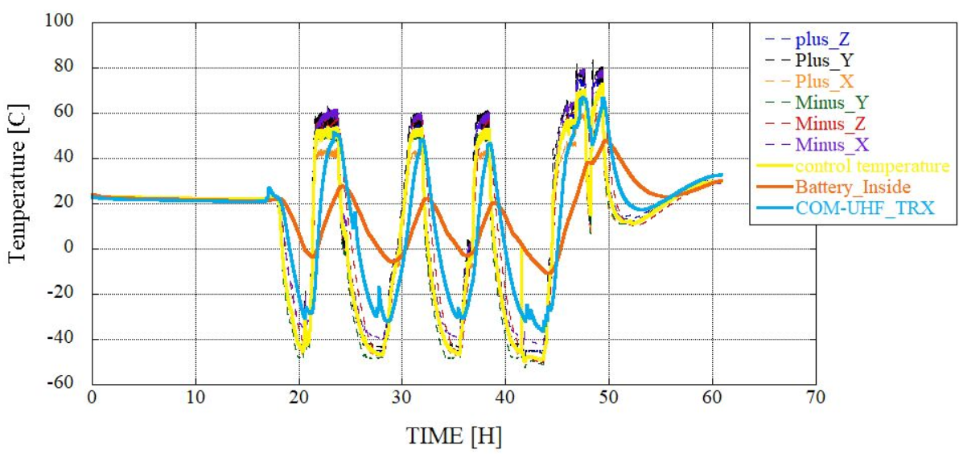

Figure 36. Temperature plots of battery and COM-UHF TRX board throughout the test

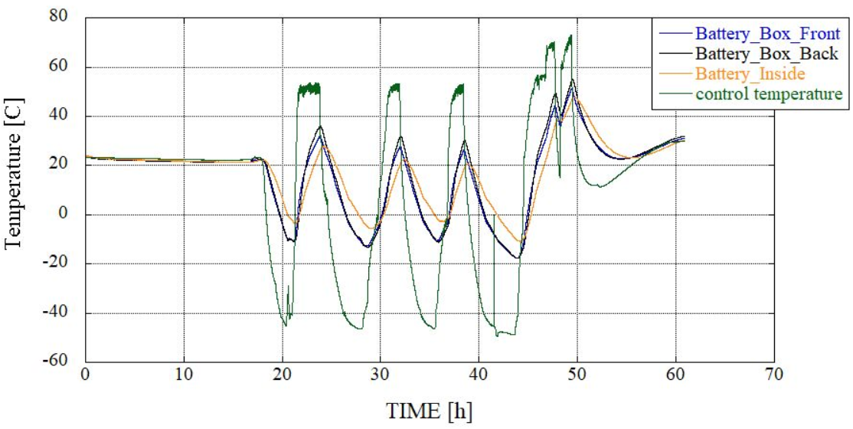

Figure 37. Temperature plot of battery throughout the test

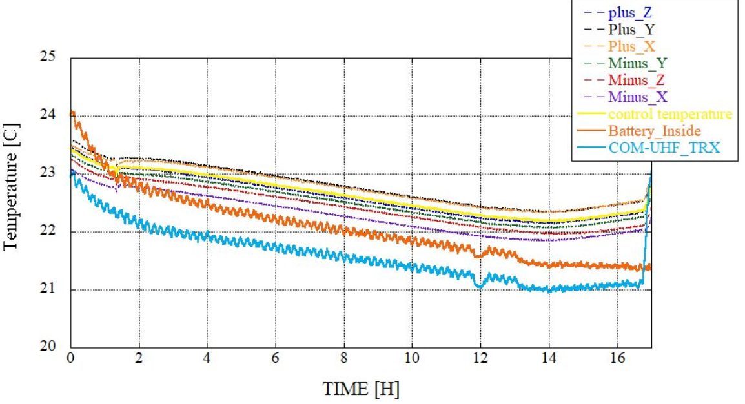

Figure 38. Temperature plots of battery and COM-UHF TRX board before LN2 injection

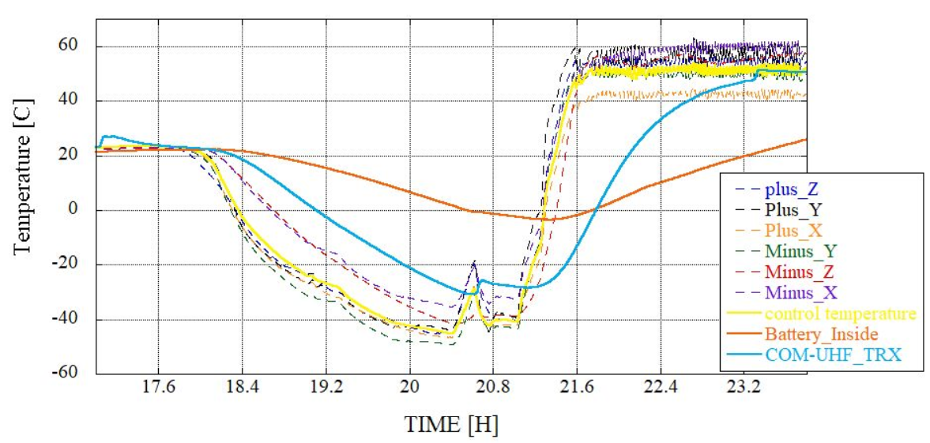

**TX on**

Figure 39. Temperature plots of battery and COM-UHF TRX board during 1st cycle

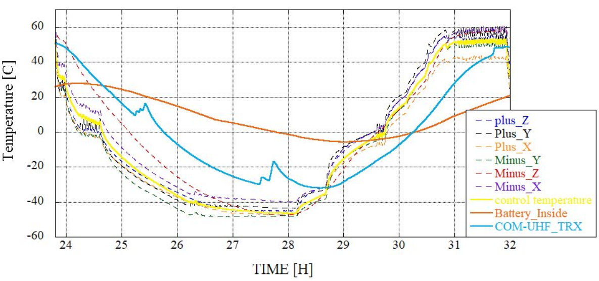

Figure 40. Temperature plots of battery and COM-UHF TRX board during 2nd cycle

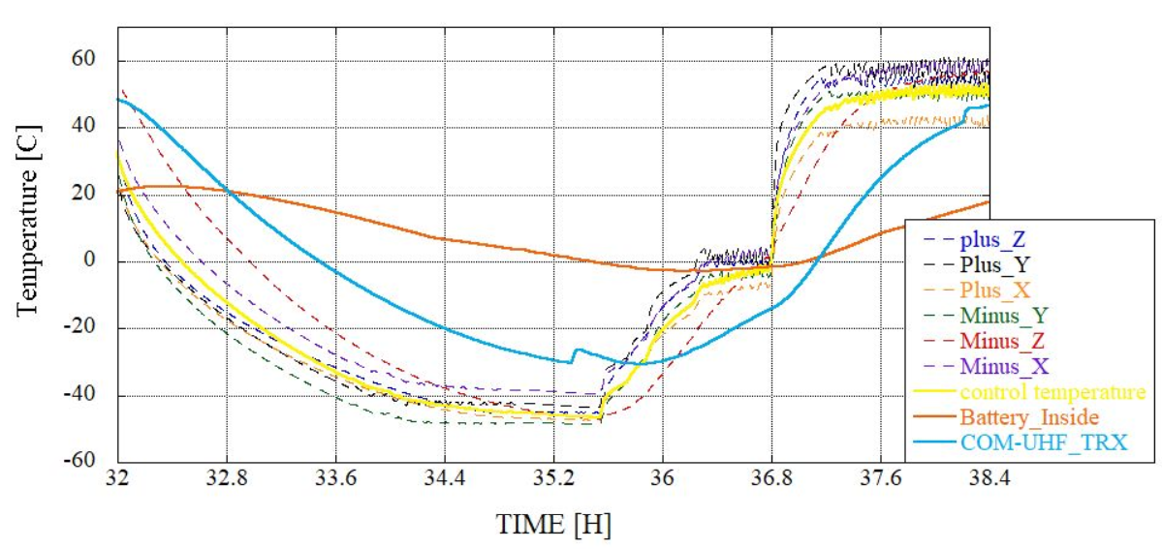

Figure 41. Temperature plots of battery and COM-UHF TRX board during 3rd cycle

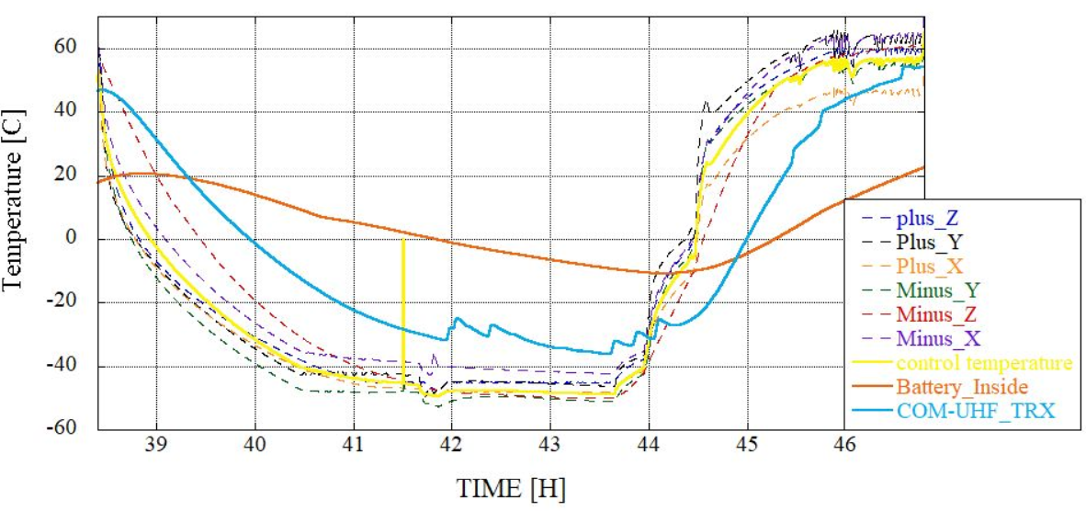

Figure 42. Temperature plots of battery and COM-UHF TRX board during 4th cycle

Fig. 42 shows an extended cold soak for the fourth cycle. The final cold soak had the temperature reach up to -10ºC. Functionality test during that time showed that the satellite still functioned as it should.

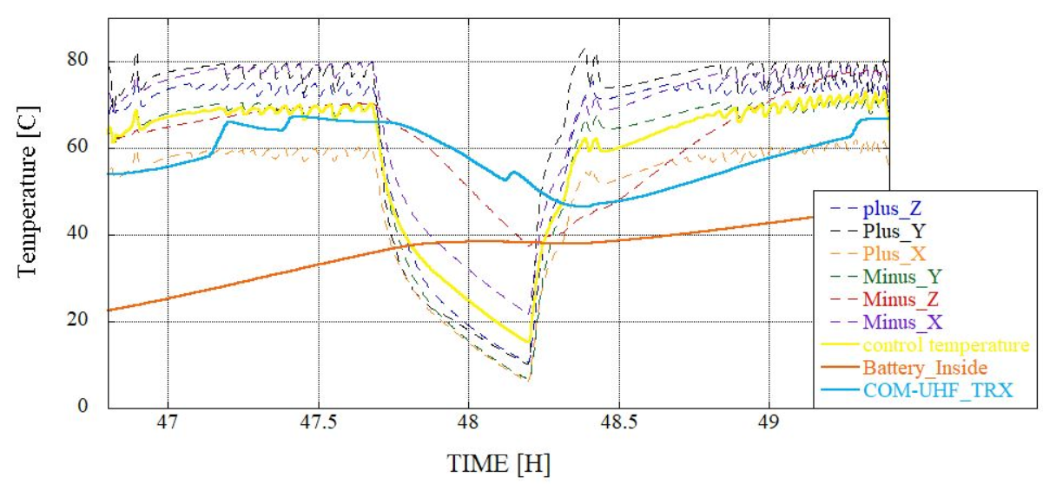

Figure 43. Temperature plots of battery and COM-UHF TRX board during extra cycle

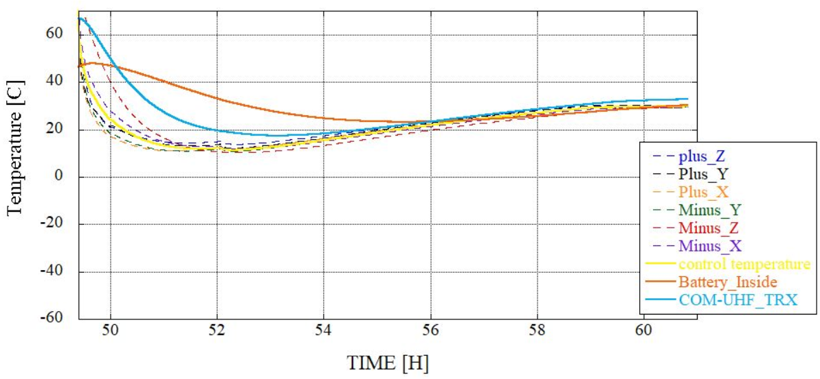

Figure 44. Temperature plots of battery and COM-UHF TRX board during recovery

### 9.1.3. FAB, OBC, LDM, Mission2 board, RAB and BPB

The temperatures of the OBC, Mission2, LDM, RAB and BPB throughout the test are plotted in Figures 45 and 46. Figures 47 to 52 provide more detailed view in each cycle. The fourth hot cycle showed functionality issue when the temperature of the OBC (Main PIC) reached over 60ºC. An extra small cycle of executed to bring the temperature of OBC down to 50ºC (where the PIC responded) and then up again to 60ºC. The OBC continued to operate this time.

Besides functional testing through the Ground Station, the satellite’s bus system was being operated through the CPLD placed on the BPB. This is part of the Japanese satellite. Since it’s the worst case, the EM for testing had the BPB. Functionality test showed no issues.

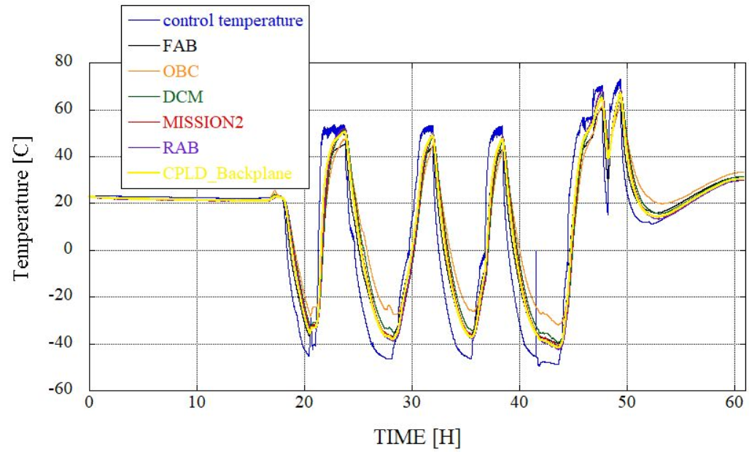

LDM

Figure 45. Temperature plots of FAB, OBC, LDM board, Mission2, RAB, BPB throughout the test (showing control temperature)

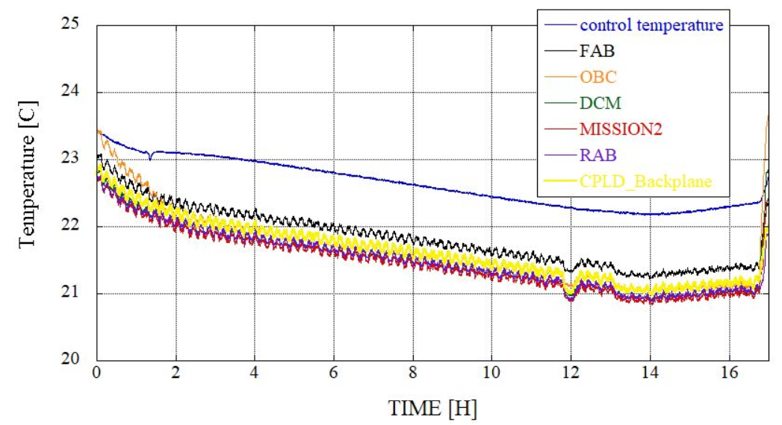

LDM

Figure 46. Temperature plots of FAB, OBC, LDM board, Mission2, RAB and BPB   
before LN2 injection

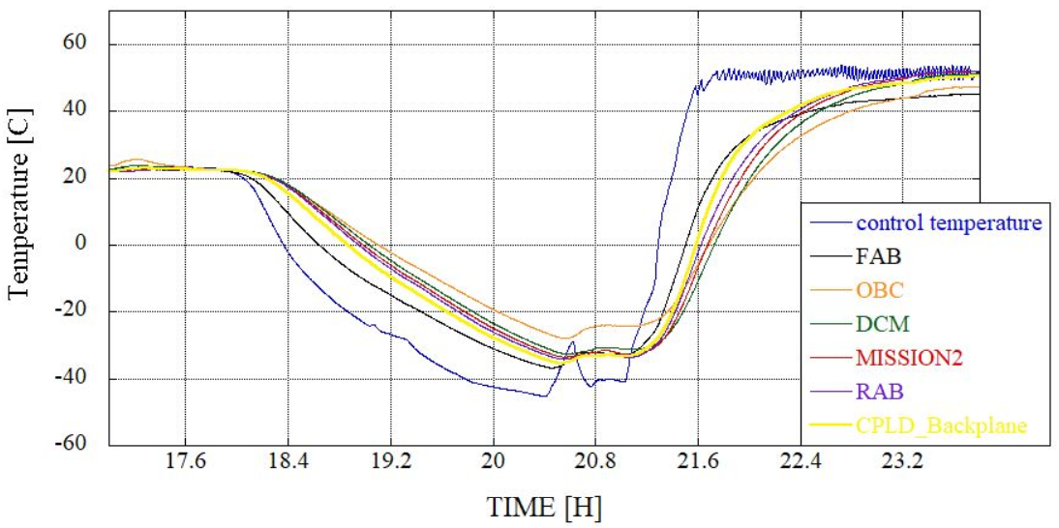

LDM

Figure 47. Temperature plots of FAB, OBC, LDM board, Mission2, RAB and BPB during 1st cycle

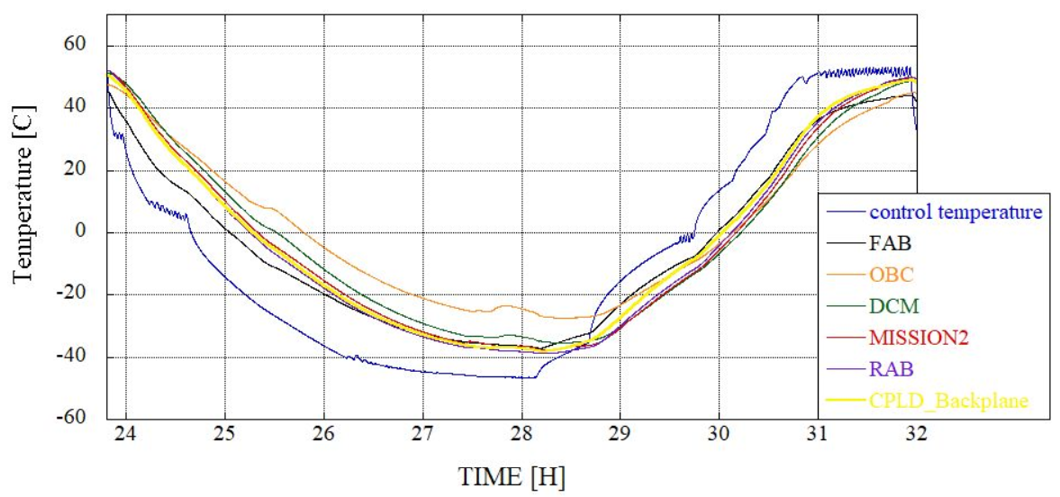

LDM

Figure 48. Temperature plots of FAB, OBC, LDM board, Mission2, RAB and BPB during 2nd cycle

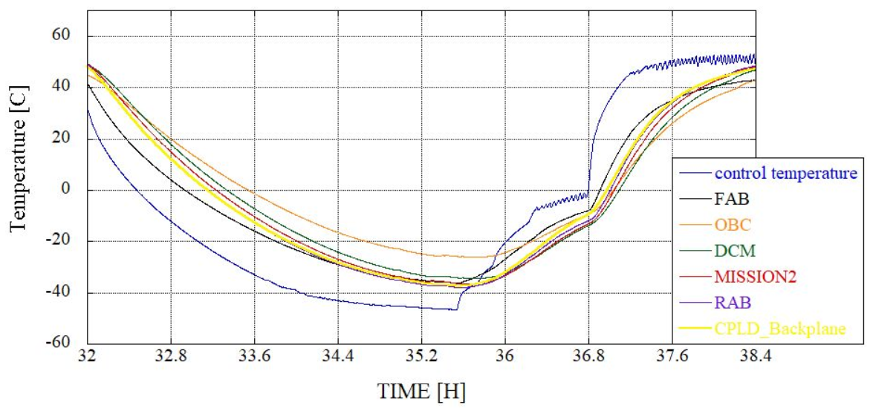

LDM

Figure 49. Temperature plots of FAB, OBC, LDM board, Mission2, RAB and BPB during 3rd cycle

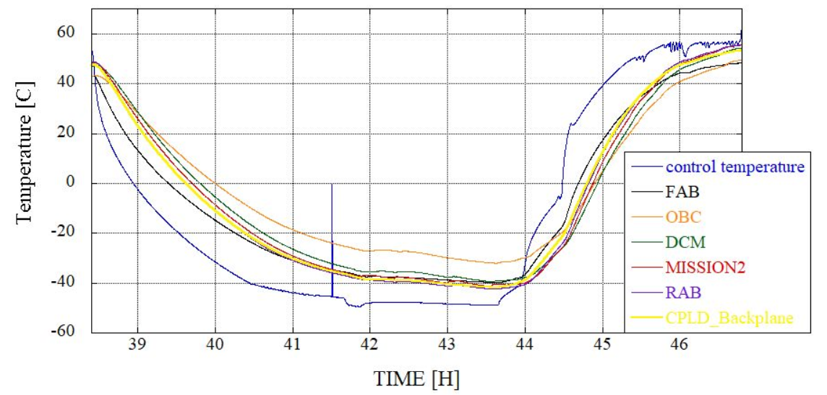

Figure 50. Temperature plots of FAB, OBC, LDM board, Mission2, RAB and BPB during 4th cycle

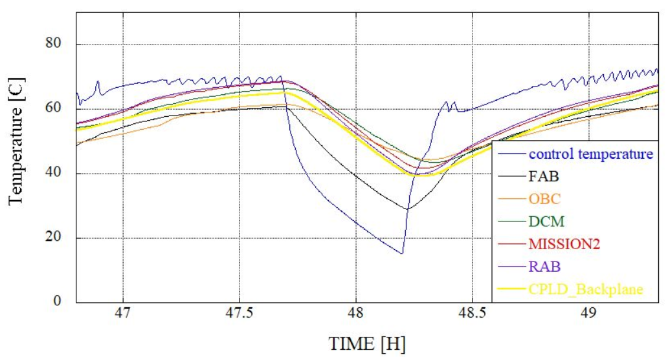

Figure 51. Temperature plots of FAB, OBC, LDM board, Mission2, RAB and BPB   
during extra cycle

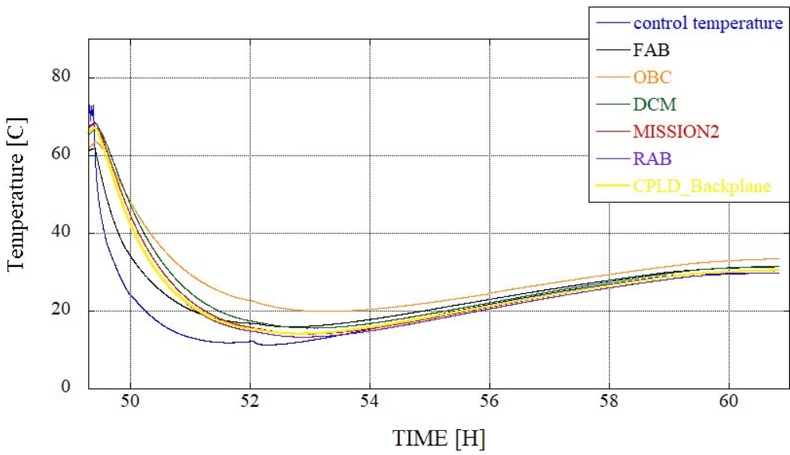

Figure 52. Temperature plots of FAB, OBC, LDM board, Mission2, RAB and BPB during recovery

### 9.1.4. Summary of Satellite Temperature Data

Table 12 provides a summary of the satellite’s external and internal temperatures which are compared to the operating temperature range of different components/subsystems.

Table 12. Summary of temperature data of subsystems during the test

|  |  |  |  |  |
| --- | --- | --- | --- | --- |
| **Subsystem** | **Operating Temperature Range** | | **Recorded Temperature During the Test**  (during stabilized temperature control and excluding error) | |
| **Lowest (°C)** | **Highest (°C)** | **Lowest (°C)** | **Highest (°C)** |
| FAB | -40 | +80 | -40 | +62 |
| OBC/EPS Board | -40 | +85 | -32 | +64 |
| Battery | +0 | +40 | -11 | +48 |
| COM-UHF TRX Board | -20 | +60 | -36 | +67 |
| LDM Board | -40 | +85 | -32 | +67 |
| Mission2 Board | -20 | +70 | -15 | +68 |
| RAB | -40 | +80 | -42 | +69 |
| CPLD Backplane | -40 | +105 | -42 | +67 |
| +X | -40 | +85 | -50 | +62 |
| -X | -40 | +85 | -43 | +80 |
| +Y | -40 | +85 | -49 | +72 |
| -Y | -40 | +85 | -53 | +76 |
| +Z | -40 | +85 | -48 | +76 |
| -Z | -40 | +85 | -50 | +78 |
| Average of External Panels | -40 | +85 | -47 | +74 |

## 9.2. Functionality Test Results and Evaluation

The results of the functionality test during the TVT are summarized in Table 13.

Table 13. Summary of functionality test results during TVT

|  |  |  |  |
| --- | --- | --- | --- |
| **Sl. No** | **Function** | **Details** | **Check (Overall)** |
| 1 | SW2 |  | O |
| 2 | Serial monitor | Main PIC | O |
| 3 | Interface between OBC and other Subsystems | OBC (60**°C**) | ∆ |
| 4 | Reset | Reset PIC ←→ Main PIC | ∆ |
| 5 | Battery Heater | ON/OFF | O |
| 6 | Beacon transmission (CW) | Received at GS | O |
| 7 | HK data |  | O |
| 8 | Uplink Command | CAM: activate/ deactivate | O |
| 9 | LDM | ∆ |
| 10 | ADCS | O |
| 11 | Downlink | CAM: activate/ deactivate | O |
| 12 | LDM | ∆ |
| 13 | ADCS | O |
| 14 | Antenna Deployment | In the worst cold (-X panel: -42**°C**) | O |

## 9.3. Battery Heater Operation

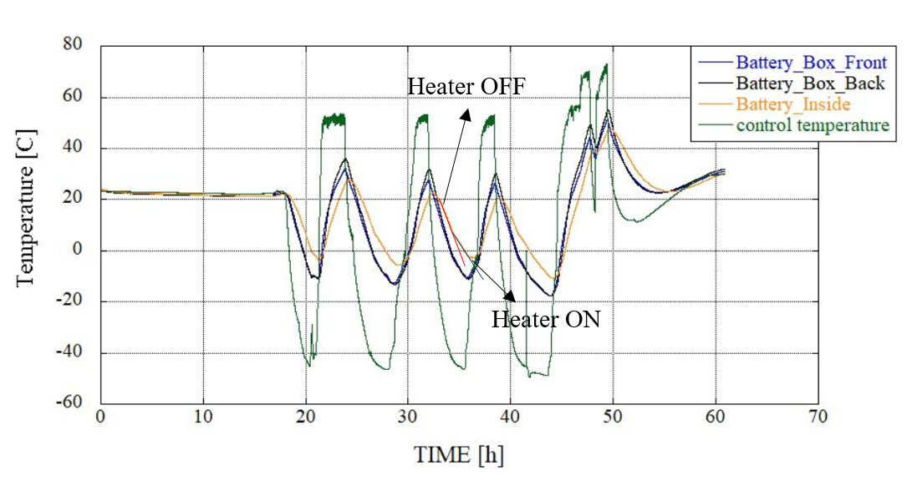

Figure 54. Temperature during antenna deployment

The heater was programmed to be turned ON when the temperature reached 8°C. Comparing to the slopes of the temperature of the external and internal side, the internal has a greater slope. This is due the insulation placed inside the battery box. Also noticeable is the increase in slope pointed out in Fig. 54. The heater further slows the rate at which temperature decreases inside the battery box. Although the heater could not keep the battery temperature above 0°C, the heater still managed to dampen the rate. The heater operated normally on all cold cycles.

## 9.4. Antenna Deployment

Figure 53 and 54 are –X panel boards which are before and after of deployment antenna. Antenna was deployed when the temperature was at -42°C. Figure 55 shows that the Nichrome wire melted the fishing string during the final cold soak. An additional string was tied such that the deployed antenna would not be fully deployed and hit the heater surrounding the satellite.

|  |  |
| --- | --- |
|  |  |
| Figure 54. Before deploying antenna | Figure 55. After deploying antenna |

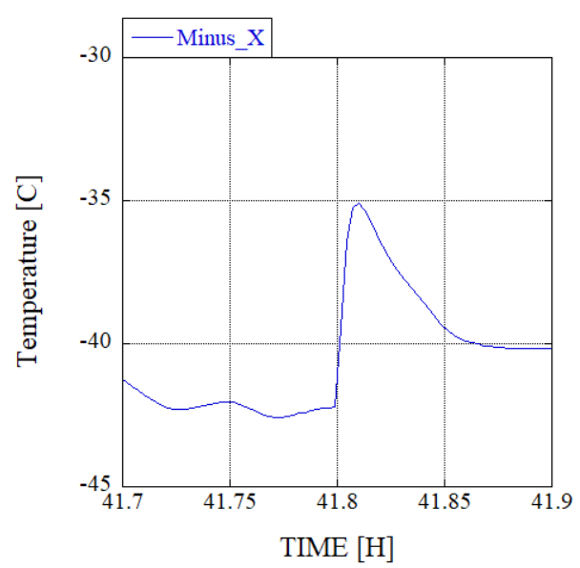

Figure 56. Temperature during antenna deployment

Fig. 56 is a snippet of the graph showing exactly when the antenna deployed. During deployment, the temperature sensor placed near the heater showed the temperature jumped from -42°C to about -35°C.